Lab Assignment – AI Assisted Coding
Name: SANITH AKULA
Year/Sem: III/II
Duration: 2 Hours

Task 0: Environment Setup – GitHub Copilot in VS Code

Question
Install and configure GitHub Copilot in VS Code.

Prompt
Install and configure GitHub Copilot in VS Code

Analysis
1. Open VS Code and go to Extensions.
2. Search for 'GitHub Copilot' and install it.
3. Sign in with your GitHub account.
4. Enable Copilot in settings.
5. Test by writing a comment and observing suggestions.

Output
Screenshots of Installation,Login and Activation.

Conclusion
Copilot successfully configured and ready to assist in coding tasks.

Task 1: AI-Generated Logic Without Modularization

Question
Reverse a string without using functions.

Prompt
Write a Python program to reverse a string without using functions

Code
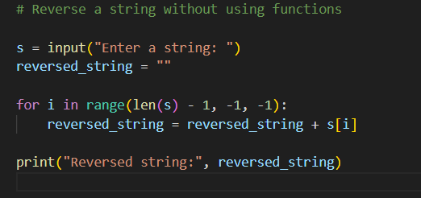

Analysis
Uses loop and indexing. No user-defined functions. Readability is moderate, but correct.

Output
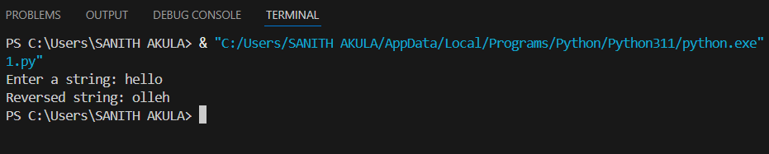

Conclusion
Procedural approach works correctly but is verbose and less readable.

Task 2: Efficiency & Logic Optimization

Question
Optimize Task 1 code for readability.

Prompt
Simplify this string reversal code

Code
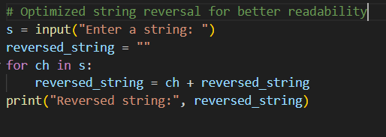

Analysis
Uses Python slicing. Removes unnecessary variables and loops. Time complexity remains O(n), readability improves.

Output
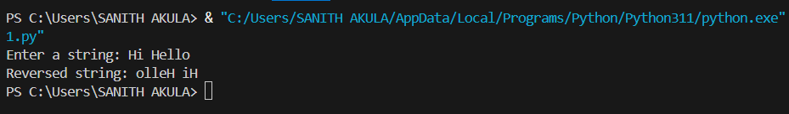

Conclusion
Optimized code is concise, efficient, and easier to maintain.

Task 3: Modular Design Using Functions

Question
Reverse a string using a function.

Prompt
Write a Python function to reverse a string with comments

Code
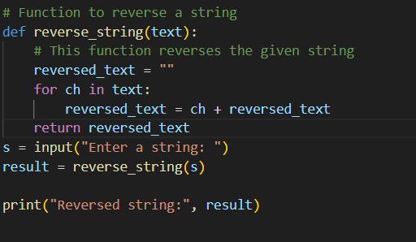

Analysis
Encapsulates logic in a reusable function. Easier debugging and reusability. AI-generated comments improve clarity.

Output
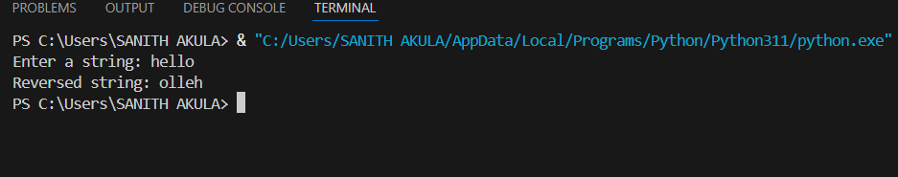

Conclusion
Modular design improves maintainability and supports reuse across applications.

Task 4: Comparative Analysis – Procedural vs Modular

Question
Compare Task 1 (procedural) vs Task 3 (modular).

Prompt
Compare procedural vs modular string reversal approaches

Analysis
Comparison of procedural and modular approaches based on clarity, reusability, debugging, and scalability.
Aspect |  |  |  |  |  |  |  |  | Procedural (Task 1) |  |  |  |  |  |  |  |  |  | Modular (Task 3)
Code Clarity |  |  |  |  |  |  |  |  | Moderate |  |  |  |  |  |  |  |  |  | High
Reusability |  |  |  |  |  |  |  |  | Low |  |  |  |  |  |  |  |  |  | High
Debugging |  |  |  |  |  |  |  |  | Difficult |  |  |  |  |  |  |  |  |  | Easy
Scalability |  |  |  |  |  |  |  |  | Poor |  |  |  |  |  |  |  |  |  | Good
Maintainability |  |  |  |  |  |  |  |  | Low |  |  |  |  |  |  |  |  |  | High

Conclusion
Modular approach is superior for scalability, clarity, and reusability.

Task 5: Iterative vs Slicing Approaches

Question
Generate loop-based and slicing-based string reversal.

Prompt
Generate iterative and slicing-based string reversal approaches in Python

Code
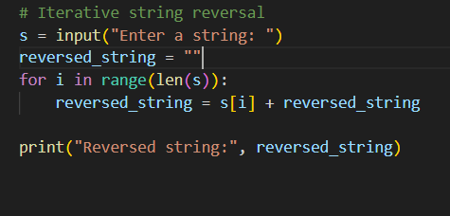

Analysis
Iterative builds reversed string step by step. Slicing uses Python’s built-in slicing. Both O(n), but slicing is faster and more concise.

Output
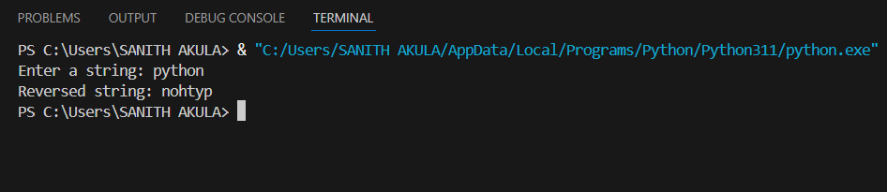

Conclusion
Iterative approach is useful for learning, slicing is preferred in production for efficiency and readability.

